Powerpoint 4 – group 4

From the textbook Comunicare storia pp. 108-112

Spanish flu pandemic
https://www.youtube.com/watch?v=xUE3nO-j_rg&list=PLW9M2Y-IcYf9NrDts7lsL67USceP-lNfQ&index=91

Use this graph to describe the 4 waves:
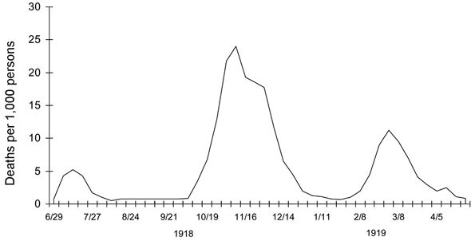

President Wilson’s 14 points
https://www.archives.gov/milestone-documents/president-woodrow-wilsons-14-points

Winners and defeated after WWI (fino a 16:46)
https://www.youtube.com/watch?v=pYVJEQA9BSg&list=PLB2vhKMBjSxPELldzw4nTcUxbxlogN2L1&index=6

Show political maps of Europe before and after WWI to explain borders changes.

DOMANDE E/O QUESTIONI DA TRATTARE NELLA PRESENTAZIONE

- The Spanish flu pandemic: does it start in Spain? Why is it so called? How many waves are there? The highest rate of mortality concerns which part of the population? When does it end, and why? Use some data and show the graph.
- Are there vaccines or antibiotics?
- Is there a lockdown in Europe or USA?
- Does the pandemic have an economic repercussion?
- Find online some photos of people with masks against Spanish flu.
- What is the Nations’ League?
- Summarize Wilson’s 14 points.
- Which are the economic conditions of winners and defeated after WWI?
- What does Keynes say in his book The economic consequences of the peace?
- How German debts keep growing?
- Why does violence increase in Germany?
- Show a map with new European borders after peace treaties.

